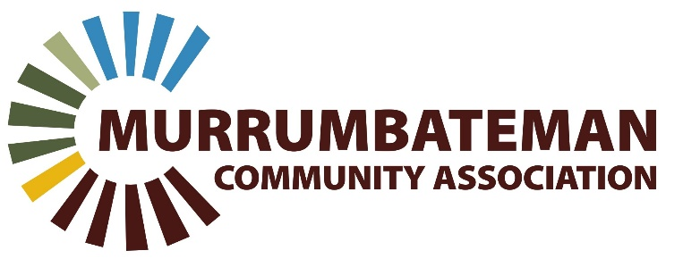

Murrumbateman Community Association Inc. (MCA)
19 East Street, Murrumbateman NSW, 2582
Email: secretary@murrumbateman.org.au
Tel: (02) 6227 5895 ABN: 71 920 635 074

APPLICATION FOR MEMBERSHIP/RENEWAL

The Murrumbateman Community Association Inc. (MCA) is a voluntary, not for profit, community-based association operating in the Murrumbateman and region in New South Wales. It is an overarching body that assists community members to conduct their activities with appropriate legal and statutory cover, representation and other support.
MPA Staff Signature/Initials: …………………

1. GENERAL INFORMATION
Name: Address: _______________________________________________
Email:___________________________________________
Phone/Mobile:

Date:

MEMBERSHIP YEAR:

2. MEMBERSHIP TYPE New Membership Membership Renewal
OTHER AFFILIATION:
(Optional)
Field Days Menshed
ACCWS
Market
3. PAYMENT DETAILS

Membership Fee: $20.00 including GST

Date of payment: / /

Cash: In person at 19 East Street, Murrumbateman NSW, 2582
Direct Deposit:
BSB: 032 771
Account Number: 229897
Reference: [Name] MPA Membership
OFFICE USE ONLY

Date:

Paid: Yes / No

If NEW member, membership accepted: Yes / No
MCA Membership/Renewal Form

