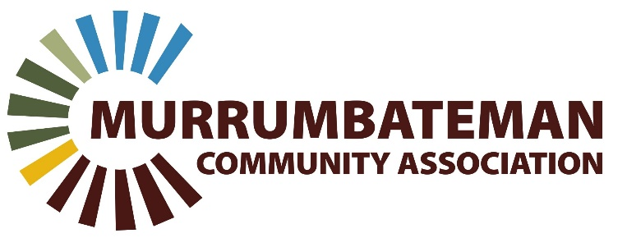

Murrumbateman Community Association Inc
19 East St, Murrumbateman NSW, 2582
Tel: (02) 6227 5895
ABN: 71 920 635 074

Strategic Outlook 2023-2028
Background
The Murrumbateman Progress Association (MPA) has supported the Murrumbateman community since its formation on 2 March 1936 as the Murrumbateman Agriculture Bureau and Progress Association. It was renamed the MPA in 2014. It operates as a not-for-profit association and promotes the rural-residential lifestyle, activities and services for the Murrumbateman community.
Our vision – What we want for Murrumbateman
A vibrant and sustainable Murrumbateman region community.
Our purpose – The reason the MPA exists
Working for the benefit of the Murrumbateman community through representation and advocacy of its interests.
Our objectives – The outcomes we want to achieve for Murrumbateman
- Provide a forum where the community can involve themselves in issues pertaining to Murrumbateman
- Be an umbrella body to act on issues of general concern to the whole or significant portion of the community
- Promote the development of facilities, activities and infrastructure that benefits the whole community
- Facilitate engagement with and between Murrumbateman community groups
- Promote, run and support community events and interest groups
- Inform the community about issues and events
- Attract and recruit membership that’s representative of the community
- Serve as a community voice with local, State and Federal government.
Our principles – The values and practices we apply to everything we do
- Good governance and compliance
- Open and fair engagement
- Integrity
- Inclusivity
- Adaptability
- Respecting and valuing the traditional owners of this land
- Respecting all people in our community
- Commitment to the environment
- Transparent and accountable financial management

Our strategies – What we do to make it happen
Advocacy and representation - We work with governments and other stakeholders to:
- Represent the community views on significant planning, development, recreation facilities, heritage and environmental issues, provision of services and at local government advisory committees
- Convene public meetings and/or facilitate consultation on issues of community interest
- Act as the responsible body for special interest and affiliated community groups by providing legal and statutory cover, representation and support
- Organise or assist a range of community social, fund-raising activities and events
- Assist in the management and facilitate maintenance of community lands
- Progress work on issues/events through working groups (WG) or sub-committees (SC)
- Provide advice and support for community groups in seeking grant funding.
Activities and deliverables - What we deliver (but not limited)
- Promotion of social events
- Recreation facilities (WG)
- Master planning consultations
- Village Markets (SC)
- Community information sharing
- Menshed (SC)
- Murrumbateman Field Days
- Christmas Carols (WG)
- History Group (WG)
- Outdoor movie screening
Projects – What we are planning or supporting
- Development and delivery of recreation facilities in Murrumbateman (through community influenced agreed priorities)
- Events and activities that bring the community together
- Promoting and supporting local businesses, sports, and community groups
- Monitoring, supporting or applying for grants to deliver facilities and improvements in Murrumbateman
- An agreed Murrumbateman Masterplan that reflects the community’s changing needs and future growth areas
- Endorsed and funded maintenance program for facilities, infrastructure and community lands
- Lobbying for construction of a new Murrumbateman Community Hall
Our Finances - We manage MPA Finances by:
- Applying sound, legal and transparent accounting processes
- Seeking income and funding sources for infrastructure, facilities and activities
- Producing an annual budget and financial plan that shows how funds are used for community benefit.

